TCP CLIENT-SERVER USING SOCKET PROGRAMMING IN PYTHON
EXPT.NO: 2
AIM: To implement TCP client-server communication using socket programming in python.
ALGORITHM:
SERVER:
- Create a socket using socket.socket().
- Bind the socket to an IP and port using bind().
- Listen for client connections using listen().
- Accept client connection using accept().
- Receive data using recv().
- Send response using send().
- Close connection.
CLIENT:
- Create a socket using socket.socket().
- Connect to server using connect().
- Send data using send().
- Receive response using recv().
- Close connection.
CODE:
SERVER:
import socket
sockfd=socket.socket(socket.AF_INET, socket.SOCK_STREAM)
print('Socket Created')
sockfd.bind(('localhost',55555))
sockfd.listen(3)
print('Waiting for connections')
while True:
clientfd,addr=sockfd.accept()
receivedMsg=clientfd.recv(1024).decode()
print("Connected with ",addr)
print("Message Received from Client: ",receivedMsg)
clientfd.send(bytes(receivedMsg,'utf-8'))
print("Message reply sent to Client!")
print("Do you want to continue(type y or n):")
choice=input()
if choice=='n':
break
CLIENT:
import socket
clientfd=socket.socket(socket.AF_INET, socket.SOCK_STREAM)
clientfd.connect(('localhost',55555))
name=input("Enter your message:")
clientfd.send(bytes(name,'utf-8'))
print("Message Received from Server: ",clientfd.recv(1024).decode())

INPUT: 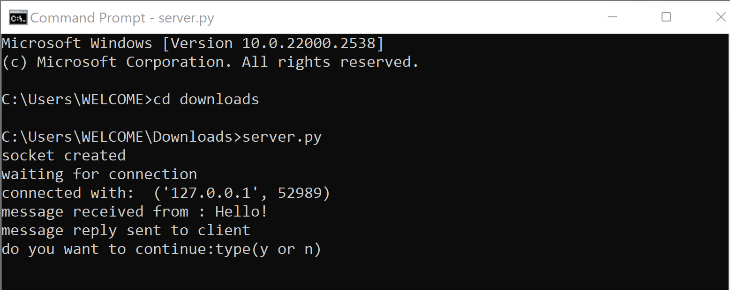

OUTPUT:
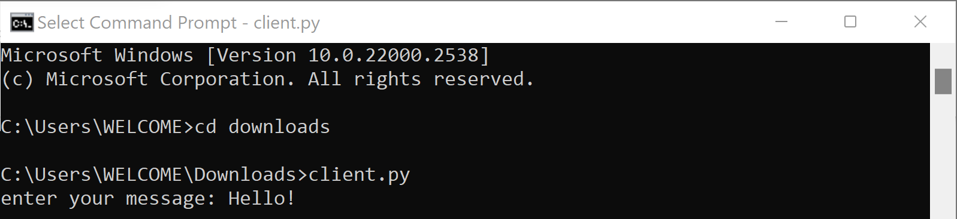
RESULT:
Thus, the TCP client-server communication was successfully implemented using python.

